**Fertile Crescent: Group Questions**

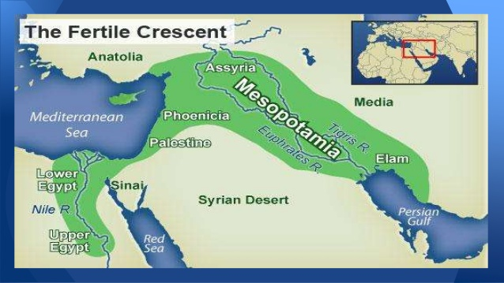

**Each group will be assigned a specific questions in Part 1 or 2

and A, B, C, D.

**Steps**:

* Brainstorm and take notes to discuss the answer to your questions.
* Cite text evidence from your notes or textbook.
* Record the answer in your notes and then log-in to padlet.com to complete your answer on our class wall.
* All answers will be shared as a class.
* You will be evaluated (exit slip) from self/group reflection to your response comment to another groups answer and relate it to the influence on the lives of the people of Mesopotamia.

**PART 1:**

1. **Identify** the ways the civilization developed from the river.
2. **Explain** the ways the irrigation system is similar to the world today.
3. **Compare** and **contrast** the ways geography helps the land.
4. **Analyze** the society of Mesopotamia and how it is similar to today’s society.

**PART 2:**

1. **Identify** the ways irrigation works.
2. **Compare** and **contrast** the ways rivers affect Mesopotamia.
3. **Explain** how the division of labor was created and how irrigation connects to it.
4. **Analyze** the creation of the jobs and government in Mesopotamia and explain how it relates to today’s world.

__________________________________________________________________

Checklist- Be sure to include: 

* Topic sentence ______
* Restate the question ______
* 2 facts from the book or your notes ______
* Supporting details ______
* Cite text evidence ______
* Conclusion sentence ______